Course Information
Course Number: DAEN 459
Course Title: Capstone Senior Design Planning
Section: 500
Time: MW 9:10-10:00 AM, F 9:10-11:10 AM
Location: ZACH 211, ZACH 344
Credit Hours: 3 (2 hours of lecture, 3 hours of lab per week)

Instructor
Instructor: Alexander Abuabara
Email: abuabara@tamu.edu
Zoom: https://tamu.zoom.us/my/abuabara
Office: ETB 4013
Office Hours: W 1:00-3:00 PM (or by appointment)

Course Description
First in a two-course sequence for the capstone senior design experience; formation of a senior design team, visitation with the team sponsor, preparation of the groundwork for the project, preparation of the project charter and collection or acquisition of initial set of data; provision of instructions on different aspects of capstone design, including ethics, design constraints, applicable standards, project management, report writing specifications and requirements, and oral and visual presentations.

Learning Outcomes
By the end of the course, students should have:
- a fully scoped capstone project,
- sponsor-approved requirements,
- architecture and infrastructure plans,
- initial datasets collected/acquired,
- governance and ethics analysis,
- project schedule and risk plan,
- prototype or proof-of-concept,
- professional proposal and presentation.

Pedagogical Model:
Semester 1 = "Design and De-risk" | Semester 2 = “Build and Deploy”
Students should:  - define the problem,  - acquire data,  - validate feasibility,  - design the system,  - produce operational plans. | Students:  - implement,  - test,  - iterate,  - evaluate,  - present final system.

Course Prerequisites Course Corequisites Special Course Designation
Grade of C or better in DAEN 301 DAEN 400, DAEN 427, and DAEN 429 None

Course Expectations
As a data engineering student, you are expected to apply the skills and knowledge developed throughout your academic career toward the planning and development of a substantial, real-world data-centric project. These expectations mirror professional data engineering roles, preparing you for collaborative, cross-functional work. You are expected to:
- Contribute actively to your team with clear communication, accountability, and collaboration,
- Attend all meetings, meet deadlines, contribute to team decisions, and resolve conflicts professionally,
- Work with stakeholders to define and refine technical and business requirements,
- Develop a detailed project plan with timelines, data needs, and deliverables,
- Address ethical, privacy, and risk considerations,
- Identify, acquire, clean, and validate datasets, including the elaboration of data dictionaries and relevant metadata,
- Design a robust data architecture, including storage, pipelines, and processing frameworks,
- Document data flow, system architecture, and all planning and data engineering decisions with supportive analysis,
- Present project components clearly to both technical and non-technical audiences,
- Deliver a comprehensive design proposal with diagrams, models, and a clear roadmap,
- Track progress through milestone reviews and maintain an updated project board,
- Manage scope, time, and resources, adjusting plans as needed,
- Apply best practices in version control, reproducibility, and testing,
- Ensure compliance with industry standards, regulations, and school policies, and
- End the course with a feasible, well-scoped project ready for implementation.

Recommended/Reference Textbooks
- Fundamentals of Data Engineering. J. Reis, M. Housley (2022)
- Designing Data-Intensive Applications. M. Kleppmann (2017)
- The Data Warehouse Toolkit. R. Kimball, M. Ross (2013)

Grading Policy
- Graded items and weights:
Deliverable | Weight
1. Team professionalism & participation | 10%
2. Project charter | 10%
3. Requirements specification | 10%
4. Data acquisition & documentation | 10%
5. Ethics & constraints analysis | 10%
6. Architecture design | 15%
7. Prototype/feasibility | 10%
8. Project management artifacts | 10%
9. Final proposal/report | 10%
10. Final presentation | 5%
- In addition to the graded items listed above, other submissions will be evaluated on a satisfactory/unsatisfactory basis. Details of these requirements and milestones will be posted on the Canvas course page and may include review sessions as well as meetings with sponsors and advisors to discuss strategies.
- Grades will be calculated by totaling the points you earn and comparing them to the max. possible points.
- Grades assigned are A: 90%–100%, B: 80%–89.9%, C: 70%–79.9%, D: 60%–69.9% and F for less than 60%.

Graded Class Participation – None Graded Attendance – None

Grades for Stacked Course – N/A Grading Policy Changes – No changes after the
second class; report issues promptly.

Late Work Policy
Late work will not be accepted except for approved university excused absences. Excused absences apply only to attendance and in-class activities and do not extend assignment deadlines. Alternatives must be arranged prior to deadline. Late work will be assigned a score of zero. Disagreements regarding a grade received on any graded material must be discussed within one week of the return of the graded material. No grade will be changed beyond this limit. If you request a regrade, the entire submission will be regarded.

Course Assignments
Initial guidelines are in the appendix; detailed instructions will be shared in class.

All submissions and presentations are formal, graded deliverables and must be uploaded to Canvas as assigned. All team members must participate, with leadership rotating across the team. Teams should hold a brief debrief after presentations.
The course concludes with a final poster presentation of each team's capstone project plan. All DAEN capstone teams participate.

Teams are formed by the instructor based on preferences or direct project assignment. Each team has an ISEN faculty advisor, with the instructor guiding the course and the sponsor serving as the client.

Faculty Advisor – Each team must have a faculty advisor from the ISEN department, and the instructor can suggest advisors who fit the project. The advisor is your subject matter expert, offering guidance and suggestions along the way. Teams should meet with their advisor every two weeks unless the advisor approves a different schedule. Faculty advisors are actively involved and considered part of your team, so treat them with respect and courtesy.

Additional Faculty Advisor – Teams can add a secondary advisor after checking with the course instructor. These advisors can be from any Texas A&M department or affiliated organization. If you want an advisor from outside Texas A&M, you'll need written approval from the instructor. The request should include their name, email, phone number, organization, area of expertise, and a short explanation of why their help would be valuable.

Course Material and Copyright
All documents used in this course are copyrighted. Here, "documents" means all materials generated for this class, including, but not limited to, course syllabi, course notes, quizzes, exams, problem sets, slide sets, and all materials appearing on the Canvas website or sent to you via email. Because these materials are copyrighted, you do not have the right to copy any of them for any purpose other than your own personal academic use unless the instructor expressly grants permission. Course materials may not be given or sold to any for-profit enterprise.

Confidentiality and Non-attribution
In this course, we will often use client data, project details, or conversations that need to stay within our group. You can share this information with classmates and the teaching team, but not outside the course. To keep things confidential, store notes or files in a safe way (like a folder, binder, or password-protected device) and keep them with you or in a secure place (room, backpack, car). Non-attribution means focusing on ideas, not people. Instead of saying "José said Range Rovers have reliability issues," say "I understand that Range Rovers have reliability issues." Avoid tying insights to individuals or teams.

Attendance & Class Participation
During the first two weeks, everyone meets during regular class time. Once teams are set, each team will give a technical review about every two weeks, and you're encouraged to attend other teams' sessions to see their work. The instructor may adjust the schedule or add events as needed. Attendance is required for all class sessions, sponsor meetings, and presentation days, unless you have a university-excused absence (see https://student-rules.tamu.edu/rule07).

Team Meetings – Active engagement is a key part of the capstone experience. Students are expected to fully participate in all team activities, including meetings with sponsors, faculty advisors, and internal discussions. These interactions help the project succeed while giving you opportunities to collaborate, solve problems, and practice professional communication skills. Meaningful participation benefits both you and your team throughout the course.

In team projects, everyone is expected to contribute fairly. When someone doesn't, the rest of the team carries the burden, which isn't fair. This problem, often called social loafing, can take many forms:
- Ignoring emails, texts, or calls from the team.
- Being told there's a communication issue but not fixing it.
- Expecting the team to work around your personal schedule.
- Missing meetings, showing up late, or leaving early.
- Submitting work that is incomplete, full of mistakes, or unusable.
- Working on unrelated ideas without team approval, then expecting credit.
- Attending meetings but spending more time on your phone than participating.

What’s expected of you:
- Be available, stay in touch with your team. It's your responsibility to make sure communication works.
- Do your part! All must contribute a fair share of the project. Fair doesn't always mean equal. Tasks may vary. Teams are encouraged to assign work that fits members' skills, but everyone must contribute in a meaningful way. Participation (or lack of it) will be reflected in presentations and peer reviews.
- Always show courtesy and respect! Professional behavior is always expected. Teammates are colleagues, use respectful language, and contribute in a way that shows maturity and responsibility.
- If a student consistently fails to participate, faculty may move them into a Track B Option: working alone under direct supervision. In this track, the highest possible grade is a C (if all requirements are met).
- Speak up early! If a teammate still isn't contributing after a TA discussion, let faculty know right away. Problems don't fix themselves, and waiting until the end of the semester leaves no time for solutions.

Project Sponsor Interaction – Teams should meet with the project sponsor's point of contact (POC) about once a month, adjusting as needed for the sponsor's schedule. Meetings can be by phone or video call (email doesn't count). All team members should attend unless there's a university-excused absence or a class conflict. The team and sponsor will coordinate meeting times, and only the sponsor can cancel. If a meeting is canceled or the sponsor feels the schedule isn't working, note it in your technical presentations and discuss a solution with the instructor.

Course Schedule (Tentative)

1. Introduction
Topics:
- course overview
- expectations and deliverables
- what makes a strong data engineering capstone
- overview of the two-course sequence
- examples from prior projects
Activities:
- skills inventory
- student introductions
- domain interest survey
Deliverables:
- individual interest statement

2. Team Formation & Sponsor Matching
Topics:
- interdisciplinary teamwork
- defining team roles
- sponsor communication etiquette
- stakeholder expectations
Activities:
- team formation
- sponsor/project selection
- initial sponsor meeting preparation
Deliverables:
- team roster
- sponsor contact plan

3. Problem Definition & Project Charter
Topics:
- defining engineering problems
- scope management
- measurable objectives
- identifying success metrics
Activities:
- sponsor meetings
- project brainstorming workshop
Deliverables:
- draft project charter
- preliminary scope statement

4. Requirements Engineering
Topics:
- functional vs nonfunctional requirements
- user stories
- data requirements
- operational requirements
Data engineering emphasis:
- latency
- scalability
- reliability
- governance
Deliverables:
- requirements specification

5. Data Acquisition & Source Evaluation
Topics:
- identifying data sources
- APIs
- web scraping ethics
- licensing
- storage considerations
- data quality assessment
Activities:
- initial data collection
Deliverables:
- data inventory
- source documentation

6. Ethics, Privacy, & Responsible Data Use
Topics:
- ethics in data engineering
- privacy regulations
- bias and fairness
- cybersecurity basics
- FERPA/HIPAA/GDPR awareness
Activities:
- ethics case study discussion
Deliverables:
- ethics and compliance analysis

7. System Architecture Design
Topics:
- modern data architectures
- ETL/ELT workflows
- orchestration
- cloud vs local
- data lakes/warehouses
Activities:
- architecture diagram workshop
Deliverables:
- system architecture draft

8. Design Constraints & Applicable Standards
Topics:
- engineering constraints
- technical debt
- standards and interoperability
- scalability concerns
- maintainability
Potential standards:
- JSON/Avro/Parquet
- REST
- OAuth
- metadata standards
Deliverables:
- constraints analysis
- standards documentation

9. Project Management & Agile Planning
Topics:
- Agile workflows
- sprint planning
- Git workflows
- issue tracking
- risk management
Activities:
- backlog creation
- timeline estimation
Deliverables:
- project timeline
- sprint roadmap
- risk register

10. Initial Technical Prototype
Topics:
- proof-of-concept methodology
- validating feasibility
- benchmarking
Activities:
- build minimal pipeline or ingestion demo
Deliverables:
- prototype demonstration
- feasibility report

11. Technical Writing & Documentation
Topics:
- engineering reports
- architecture documentation
- reproducibility
- citation standards
Activities:
- peer review workshop
Deliverables:
- draft technical report

12. Oral & Visual Presentation Skills
Topics:
- technical storytelling
- communicating with sponsors
- presentation design
- poster design
Activities:
- lightning presentations
Deliverables:
- presentation draft

13. Midpoint Design Review
Activities:
- formal review panel
- sponsor feedback
- faculty critique
Deliverables:
- revised architecture and scope

14. Final Proposal Preparation
Topics:
- preparing for implementation semester
- defining semester-two milestones
- handoff readiness
Deliverables:
- final proposal
- implementation roadmap

15. Final Presentations
Activities:
- formal presentations
- poster session
- sponsor evaluation
Deliverables:
- final report
- final presentation
- archived project documentation

Important Dates (https://registrar.tamu.edu/Academic-Calendar)
• Aug 25 | First day of Fall semester classes | • Nov 26 | Reading day, no classes
• Aug 29 | Last day to add/drop courses for Fall semester | • Nov 27-28 | Thanksgiving holiday, no classes
• Sep 1 | Labor day, no classes | • Dec 8 | Last day of Fall semester classes
• Oct 13-14 | Fall break, no classes | • Dec 9-10 | Reading days, no classes
• Nov 19 | Last day to Q-drop or to withdraw (by 5 PM) | • Dec 11-16 | Final exams

Tips – (i) You all are important to me: include the course number in email subject so I can prioritize it. (ii) Every step matter and each build on the next: stay engaged, keep up, ask questions. (iii) Learning takes steady effort, start early, not last-minute cramming. (iv) Engineers turn data into meaningful information, practice here, get prepared. (v) Clear, well-organized work is as important as the content itself. (vi) Use others' ideas to build your own but always credit your sources: good scholarship means giving credit where it's due. (vii) No audio or video recording without permission; it's a conduct violation otherwise.

Technology Support – For technical support contact isen-helpdesk@tamu.edu.

University Policies

Attendance Policy
The university views class attendance and participation as an individual student responsibility. Students are expected to attend class and to complete all assignments. Please refer to Student Rule 7 in its entirety for information about excused absences, including definitions, and related documentation and timelines.

Student Observances for Religious Holy Days
In accordance with Texas Education Code §51.911(b) and Texas A&M Student Rule 7: Attendance, students shall be excused from attending classes or other required activities, including examinations, for the observance of a religious holy day, including travel for that purpose. For more information about excused absences due to religious holy days, please visit the Faculty Affairs website (under Other University Guidelines).

Makeup Work Policy
Students will be excused from attending class on the day of a graded activity or when attendance contributes to a student’s grade, for the reasons stated in Student Rule 7, or other reason deemed appropriate by the instructor. Please refer to Student Rule 7 in its entirety for information about makeup work, including definitions, and related documentation and timelines.
Absences related to Title IX of the Education Amendments of 1972 may necessitate a period of more than 30 days for make-up work, and the timeframe for make-up work should be agreed upon by the student and instructor” (Student Rule 7, Section 7.4.1).

“The instructor is under no obligation to provide an opportunity for the student to make up work missed because of an unexcused absence” (Student Rule 7, Section 7.4.2).

Students who request an excused absence are expected to uphold the Aggie Honor Code and Student Conduct Code. (See Student Rule 24.)

Academic Integrity Statement and Policy
“An Aggie does not lie, cheat or steal, or tolerate those who do.”

“Texas A&M University students are responsible for authenticating all work submitted to an instructor. If asked, students must be able to produce proof that the item submitted is indeed the work of that student. Students must keep appropriate records at all times. The inability to authenticate one’s work, should the instructor request it, may be sufficient grounds to initiate an academic misconduct case” (Section 20.1.2.3, Student Rule 20).

You can learn more about the Aggie Honor System Office Rules and Procedures, academic integrity, and your rights and responsibilities at aggiehonor.tamu.edu.

Plagiarism Policy
According to the Texas A&M University Definitions of Academic Misconduct, plagiarism is the appropriation of another person's ideas, processes, results or words without giving appropriate credit (aggiehonor.tamu.edu). You should credit your use of anyone else's words, graphic images, or ideas using standard citation styles. AI text generators (ChatGPT, Google Bard, etc.) should not be used for any work for this class without explicit permission of the instructor and appropriate attribution. This includes, but is not limited to:
- Creating or revising drafts
- Editing your work
- Reviewing a peer's work
This excludes pre-existing software additions such as spelling and grammar checkers, which are acceptable.

Such use of AI text generators in this manner could be considered plagiarism and cheating according to Student Rule 20. More information may also be found at https://aggiehonor.tamu.edu or you may contact your instructor if you have questions.

Americans with Disabilities Act (ADA) Policy
Texas A&M University is committed to providing equitable access to learning opportunities for all students. If you experience barriers to your education due to a disability or think you may have a disability, please contact the Disability Resources office on your campus (resources listed below) Disabilities may include, but are not limited to attentional, learning, mental health, sensory, physical, or chronic health conditions. All students are encouraged to discuss their disability related needs with Disability Resources and their instructors as soon as possible.

Disability Resources is in the Student Services Building or at (979) 845-1637 or visit disability.tamu.edu.

Title IX and Statement on Limits to Confidentiality
Texas A&M University is committed to fostering a learning environment that is safe and productive for all. University policies and federal and state laws prohibit gender-based discrimination and sexual harassment, including sexual assault, sexual exploitation, domestic violence, dating violence, and stalking.
With the exception of some medical and mental health providers, all university employees (including full and part-time faculty, staff, paid graduate assistants, student workers, etc.) are Mandatory Reporters and must report to the Title IX Office if the employee experiences, observes, or becomes aware of an incident that meets the following conditions (see University Rule 08.01.01.M1):
- The incident is reasonably believed to be discrimination or harassment.
- The incident is alleged to have been committed by or against a person who, at the time of the incident, was (1) a student enrolled at the University or (2) an employee of the University.

Mandatory Reporters must file a report regardless of how the information comes to their attention – including but not limited to face-to-face conversations, a written class assignment or paper, class discussion, email, text, or social media post. Although Mandatory Reporters must file a report, in most instances, a person who is subjected to the alleged conduct will be able to control how the report is handled, including whether to pursue a formal investigation. The University’s goal is to make sure you are aware of the range of options available to you and to ensure access to the resources you need.

Students wishing to discuss concerns related to mental and/or physical health in a confidential setting are encouraged to make an appointment with University Health Services or download the TELUS Health Student Support app for 24/7 access to professional counseling in multiple languages. Walk-in services for urgent, non-emergency needs are available during normal business hours at University Health Services locations; call 979.458.4584 for details.

Students can learn more about filing a report, accessing supportive resources, and navigating the Title IX investigation and resolution process on the University’s Title IX webpage.

Statement on Mental Health and Wellness
Texas A&M University recognizes that mental health and wellness are critical factors influencing a student’s academic success and overall wellbeing. Students are encouraged to engage in healthy self-care practices by utilizing the resources and services available through University Health Services. The TELUS Health Student Support app provides access to professional counseling in multiple languages anytime, anywhere by phone or chat, and the 988 Suicide & Crisis Lifeline offers 24-hour emergency support at 988 or 988lifeline.org.

Pregnancy Accommodations
Texas A&M provides reasonable accommodations to students due to pregnancy and/or related conditions, such as childbirth, recovery and lactation. Students should contact the University’s Pregnancy Coordinator as soon as they become aware of the need for accommodation. Depending on the circumstances, accommodations could include extended time to complete assignments or exams, changes in course sequence, or modifications to the physical classroom environment. Texas A&M will also allow a voluntary leave of absence, ensure the availability of lactation space, and maintain grievance procedures to provide for the prompt and equitable resolution of complaints of sex discrimination. For information regarding pregnancy accommodations, email TIX.Pregnancy@tamu.edu.

Appendix – Initial guidelines
This capstone course serves as an integrative, high-impact educational experience that challenges students to integrate their accumulated knowledge and apply it to a complex, real-world problem. The capstone projects encourage students to adopt a hands-on approach by building solutions from the ground up rather than relying only on existing tools or templates. The goal is to improve essential skills such as project management, communication, and interdisciplinary analysis, thereby preparing students for professional or academic success. Figure 1 provides a broad overview of how data moves through a system, highlighting the sequential steps of data engineering and the critical underlying disciplines that ensure its success.

Unlike busy work which often involves repetitive, low-cognitive tasks with limited connection to meaningful learning outcomes, the capstone project demands critical thinking, research, and collaboration. Here "reinventing the wheel" is not busy work but a deliberate method for gaining insights, building confidence, and preparing for real-world innovation. Drawing inspiration from Richard Feynman's quote, "What I cannot create, I do not understand", these are some of the great reasons to reinvent the wheel:
- Learn how wheels are made
- Teach others about wheels
- Learn about the inventors of wheels
- Be able to change wheels (or fix) when they break
- Build a better wheel (for some definition of better)
- Help someone in need of a very special wheel (maybe for a wheelchair?)
- Learn a tiny slice of what it means to build a larger system (such as a vehicle)

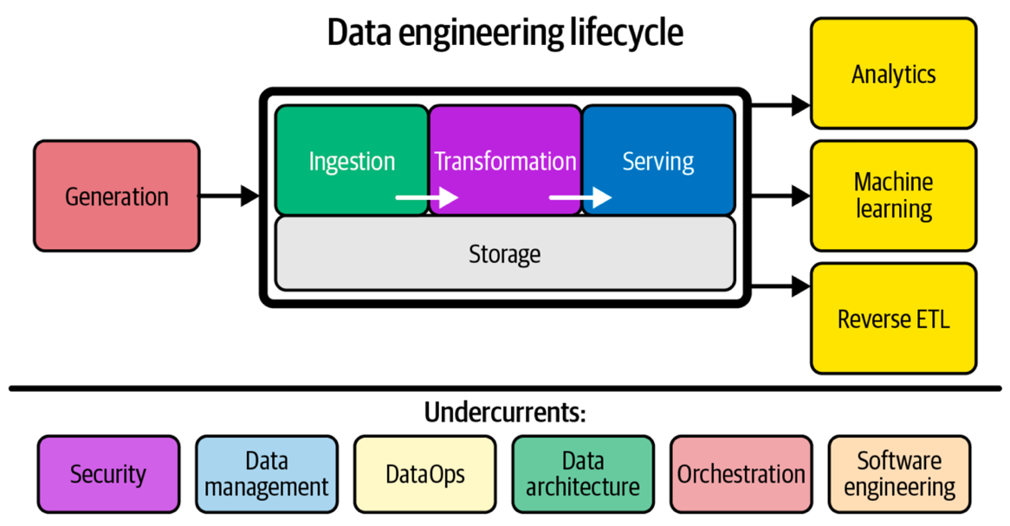
Figure 1 – Components and undercurrents of the data engineering lifecycle. Image extracted from Fundamentals of Data Engineering: Plan and Build Robust Data Systems, J. Reis, M. Housley, 2022.

V-model
The V-model (Fig. 2) provides a structured framework ideal for planning the Data Engineering Capstone Senior Design courses. It guides students from defining project goals and requirements to detailed system design and implementation. This model promotes a detailed and careful planning, iterative development, and continuous verification, helping students understand the full lifecycle of a data engineering system, from concept and design to deployment and maintenance. Each phase on the left is mirrored by corresponding testing and validation on the right, ensuring alignment between design and outcome.
Within this framework, a Project Charter is typically the first formal document, authorizing the work, defining objectives, scope, stakeholders, and approach, and giving each team the authority to access necessary resources and tools. Once the charter is approved, the Project Management Packet is assembled, detailing schedules, risks, communications, and other operational plans, and ensuring execution stays consistent with the V-model. Like a movie, the charter is the green light; the packet is the production plan. Below you have more details about the Project Charter and the Project Management Pack.

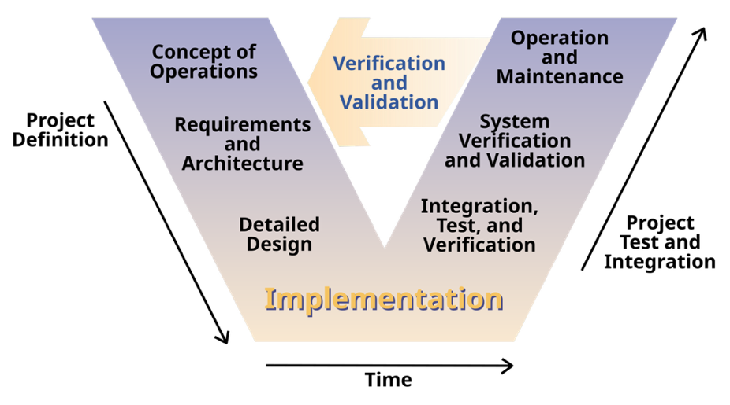
Figure 2 – Systems Engineering Process. Image extracted from Clarus: Concept of Operations, Federal Highway Administration (FHWA), 2005. (Publication No. FHWA-JPO-05-072, authors: L. Osborne, J. Brummond, R. Hart, M. Zarean, S. Conger.)

1. Project Charter
The Project Charter is a concise, authoritative document that formally authorizes a project. In a two-semester capstone sequence, the final sponsor-signed charter is the green light to proceed to implementation in the second capstone semester. Endorsed by the project sponsor, it grants the project manager and team the authority to commit organizational resources and establishes a common understanding of the project's purpose, scope, and constraints. Treat the charter as both a contract and a living reference; if conditions change, revise it formally rather than drifting informally. These are important aspects that need to be addressed in the charter:
- Authority & accountability: Sponsor sign-off clarifies who owns vision and acceptance.
- Unified vision: Forces the team to articulate a shared understanding before deep technical work.
- Baseline for changes: Scope or resource changes must be justified against the charter, avoiding unpleasant surprises.
- Early risks: Listing assumptions and constraints reveals potential (ethical/legal/technical) risks early enough to plan.
- Communication tool: Because it is short, executives and non-technical stakeholders will actually read it.

2. Project Management Packet
The Project Management (PM) Packet is a single living document that guides a data-engineering capstone team from idea approval through final hand-off. Think of it as the project's constitution that captures what you will build, how, by whom, and when so faculty, sponsors, and teammates always have one authoritative source of truth. Keep the packet lean (about 10 pages) and version-controlled, and revisit it whenever scope, risks, or constraints change. A well-maintained packet not only streamlines your work, but it also showcases professional project-management discipline to future employers. How it's used:
- Proposal phase: Submitted with your charter to secure faculty and sponsor sign-off.
- Execution phase: Updated after each sprint review; serves as the agenda for weekly stand-ups.
- Evaluation phase: Forms the backbone of your final report and memo, proving objectives were met.

Key components of the PM package and their functions:
- Work Description: Plain-language summary of what the team will build or analyze.
- Deliverables: Defines concrete outputs (code, datasets, report, poster) to hand over.
- Project Boundaries: States what is in and out to guard against scope creep.
- Acceptance Criteria: Minimum conditions the sponsor must see to sign off.
- Constraints: Non-negotiable limits (tools, data privacy, semester length, etc.).
- Assumptions: Conditions taken as true (e.g. data access) that may later change.
- Quality and Performance Metrics: How accuracy, reliability, and efficiency will be judged.
- Metrics & Verification Methods: How each metric will be measured, tested, and logged.
- Timeline and Milestones: Semester checkpoints that trigger progress reviews and pivots.
- Task Priority: Ranks tasks so critical-path items are tackled first.
- Risks & Risk Management Plans: Lists top pitfalls and the team's mitigation / contingency moves.
- Cost Estimates and Budgeting: Forecasts hours, cloud credits, and purchases to stay on budget.
- Resources: People, software, hardware, and data the project will rely on.

